**++Design Thinking Project Workbook**

**Don't find customers for your product but find products for your customers**

**1. Team**

**FAKE REVIEW SHILED**

**Team Name:**   
FAKE PRODEUCT REVIEW MONITORING SYSTEM

**Team Members:**

1. [RISHIKESHWAR, LEADER,+91 8125715564]
2. [VARSHA, ANALYST, +91 77029 47415]
3. [SAHANA, PROJECT MANAGER, +91 99665 87229]

**2. Problem/Opportunity Domain**

**Domain of Interest:**

**E-commerce and Online Retail**

**Description of the Domain: A brief overview of the key elements, challenges, and opportunities within the domain.**

The e-commerce industry has seen exponential growth, with consumers increasingly relying on online reviews to make purchasing decisions. However, the prevalence of fake reviews undermines consumer trust and distorts market competition. Key challenges include identifying fraudulent reviews, maintaining platform integrity, and ensuring customer satisfaction. Opportunities exist in developing advanced monitoring systems that leverage AI and machine learning to detect and mitigate fake reviews.

**Why did you choose this domain?: The personal or strategic reasons for selecting this domain, such as passion, market potential, or solving a specific problem.**

I chose this domain due to a passion for consumer rights and the significant impact of authentic reviews on purchasing decisions. The market potential is vast, as businesses increasingly seek solutions to enhance credibility and customer trust, making it a strategic area for innovation.

**3. Problem/Opportunity Statement**

**Problem Statement:**

Fake product reviews are very common in online shopping. This causes consumers to distrust products, make bad buying choices, and results in financial losses for businesses.

**Problem Description:**

The challenge lies in the difficulty of distinguishing genuine reviews from fraudulent ones. This not only affects consumers but also honest businesses that suffer from unfair competition.

**Context (When does the problem occur):**

The problem arises during the online shopping process when consumers rely on reviews to make informed decisions. It often peaks during promotional periods or product launches, where reviews can significantly influence sales.

**Alternatives (What does the customer do to fix the problem):**

Customers often resort to checking multiple sources for reviews, relying on personal recommendations, or avoiding products with few reviews altogether.

**Customers (Who has the problem most often): The primary group of individuals or organizations affected by the problem.**

The primary affected groups include online shoppers, e-commerce platforms, and legitimate sellers whose products are overshadowed by fake reviews.

**Emotional Impact (How does the customer feel):**

Customers feel frustrated, confused, and betrayed when they discover that reviews they relied on were fake, leading to dissatisfaction with their purchases.

**Quantifiable Impact (What is the measurable impact):**

The presence of fake reviews can lead to a significant percentage of lost sales, estimated at billions annually, alongside reputational damage for brands.

**Alternative Shortcomings (What are the disadvantages of the alternatives):**

Current solutions, like checking reviews by hand or depending on user reports, are often slow and not very effective. They can still let fake reviews slip through.

**Link to showcase the problem:**

https://www.amazon.in/gp/customer-reviews/RCY3E6OWYKH3O/ref=cm_cr_arp_d_rvw_ttl?ie=UTF8&ASIN=B0D5DFR78J

**3. Addressing SDGs**

**Relevant Sustainable Development Goals (SDGs): Identify which of the 17 SDGs are directly impacted by the problem or opportunity.**

**Goal 8:** Decent Work and Economic Growth

**Goal 12:** Responsible Consumption and Production

**How does your problem/opportunity address these SDGs?: Describe how solving the problem or leveraging the opportunity will contribute to achieving one or more SDGs.**

By ensuring the integrity of product reviews, we promote fair competition and informed consumer choices, contributing to economic growth and responsible consumption practices.

**4. Stakeholders**

Answer these below questions to understand the stakeholder related to your project

1. **Who are the key stakeholders involved in or affected by this project?**

* Consumers
* E-commerce Platforms
* Businesses/Sellers
* Regulatory Bodies

1. **What roles do the stakeholders play in the success of the innovation?**

* **Consumers:** Provide feedback and data on their experiences.
* **E-commerce Platforms:** Implement monitoring systems and policies.
* **Businesses/Sellers:** Support and adopt the system for credibility.
* **Regulatory Bodies:** Establish guidelines and standards for online reviews.

1. **What are the main interests and concerns of each stakeholder?**

* **Consumers:** Authenticity and reliability of reviews.
* **E-commerce Platforms:** Maintaining reputation and user trust.
* **Businesses/Sellers:** Fair competition and brand integrity.
* **Regulatory Bodies:** Compliance and consumer protection.

1. **How much influence does each stakeholder have on the outcome of the project?**

* **High Influence:** E-commerce Platforms, Regulatory Bodies.
* **Moderate Influence:** Businesses/Sellers.
* **Low Influence:** Consumers.

1. **What is the level of engagement or support expected from each stakeholder?**

* **E-commerce Platforms:** High engagement expected for implementation.
* **Businesses/Sellers:** Moderate support; may require incentives.
* **Consumers:** Passive engagement; feedback-driven.

1. **Are there any conflicts of interest between stakeholders? If so, how can they be addressed?**

Potential conflicts may arise between e-commerce platforms want to maintain a large volume of reviews and the need to ensure their authenticity. Addressing this requires transparent policies and collaboration.

1. **How will you communicate and collaborate with stakeholders throughout the project?**

Regular updates, user feedback sessions, and collaborative workshops will be essential for maintaining stakeholder engagement.

1. **What potential risks do stakeholders bring to the project, and how can these be mitigated?**  
   Stakeholders may resist change due to concerns over costs or complexity. Mitigation strategies include clear communication of benefits and phased implementation.

**5. Power Interest Matrix of Stakeholders**

**Power Interest Matrix: Provide a diagrammatic representation of Power Interest Matrix**

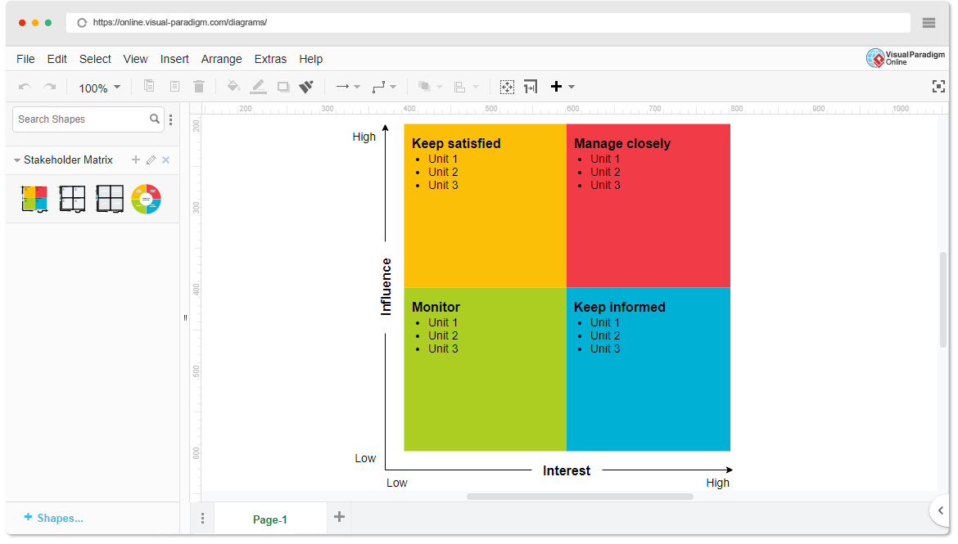

* High Power, High Interest: [E-commerce Platforms]
* High Power, Low Interest: [Businesses/Sellers]
* Low Power, High Interest: [Regulatory Bodies]
* Low Power, Low Interest: [Consumers]

1. **Empathetic Interviews**

**Conduct Skilled interview with at least 30 citizens/Users by asking open ended questions (What, why/How etc) and list the insights as per the format below**

|  |  |  |
| --- | --- | --- |
| **I need to know**  **(thoughts, feelings, actions)** | **Questions I will ask**  **(open questions)** | **Insights I hope to gain** |
| Thoughts | What do you think about online reviews? | |  | | --- | | Understanding of consumer perceptions about the reliability of reviews. | |  | |
|  | Why do you trust certain reviews over others? | |  | | --- | | Insights into factors that influence trust in reviews. | |  | |
|  | How do you decide which products to buy based on reviews? | |  | | --- | | Awareness of decision-making processes related to reviews. | |  | |
| Feelings | How do you feel when you find a fake review? | |  | | --- | | Emotional impact of encountering fake reviews. | |  | |
|  | Why is it important for you to see real reviews? | |  | | --- | | Understanding the value consumers place on authenticity. | |  | |
|  | What emotions do you experience when a product doesn't meet your expectations after reading reviews? | |  | | --- | | Insights into disappointment and frustration levels. | |  | |
| actions | What steps do you take if you suspect a review is fake? | |  | | --- | | Understanding of consumer behaviour when faced with suspicious reviews. | |  | |
|  | How do you verify the authenticity of reviews before making a purchase? | |  | | --- | | Awareness of methods used to check for genuine reviews. | |  | |
|  | What do you do if you have a bad experience with a product that had good reviews? | Insights into consumer responses to misleading information. |

**SKILLED INTERVIEW REPORT**

**(Examples are given. Erase them and fill with your user information.)**

|  |  |  |
| --- | --- | --- |
| **User/Interviewee** | **Questions Asked** | **Insights gained (NOT THEIR ANSWERS)** |
| Abhishek Verma,  Student | Which party do you vote for? | Citizens are not very open about their political preferences |
| Srinivasan P., Parent | How do you feel about the plans for a new capital? | Some citizens are sad that the capital is being relocated from Hyderabad. |
|  |  |  |
|  |  |  |
|  |  |  |

**Key Insights Gained:**

* **Insight 1**

These systems don't just look for obvious fake words. They use computers to understand how people write, and to notice when something seems off, like if a bunch of reviews sound too similar, or if someone's writing style changes a lot.

* **Insight 2**

The point of these systems is to make sure the reviews you read are real. This helps you know if a product is actually good, and it keeps companies from tricking you with fake praise.

**Empathy Map**

1. **Empathy Map**

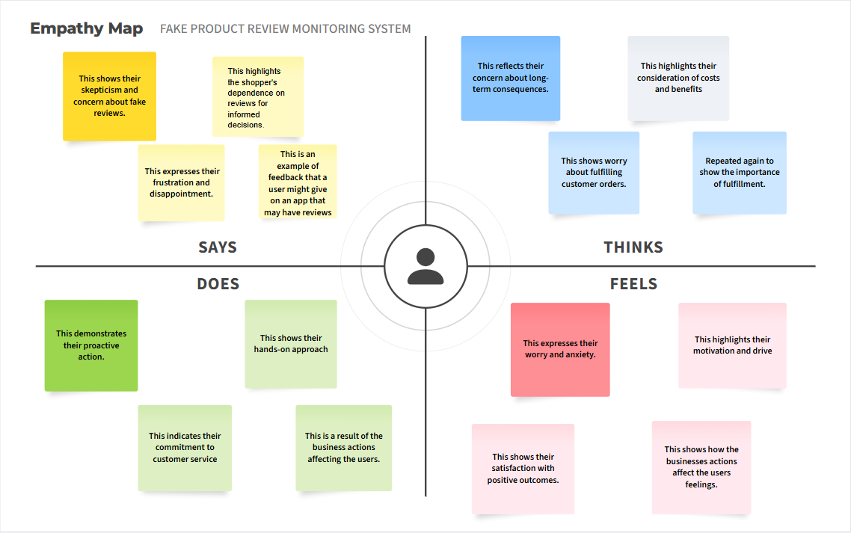

1. **Who is your Customer?**

**Description: This is where you specify the customer or user you are empathizing with. It could be a specific user persona or a general user segment.**

**Key points:**

* **Define the customer profile clearly (e.g., age, profession, interests).**
* **State their goals and needs related to the innovation or product.**
* **Context in which the user will interact with your solution.**

1. **Who are we empathizing with?**

**Description: This area helps you define who the user is, what their situation looks like, and what role they play. It emphasizes understanding the user’s perspective in depth.**

**Key points:**

* **Define the user's characteristics (e.g., personality, values, and responsibilities).**
* **State the user's goals and challenges in their environment.**
* **What is the user's broader situation (professionally or personally)?**

1. **What do they need to DO?**

**Description: This section identifies what actions or tasks the user needs to perform. It helps highlight the expectations and demands the user faces.**

**Key points:**

* **Clarify the tasks or actions the user needs to complete.**
* **What decisions do they need to make?**
* **How do they define success or failure in their tasks?**

1. **What do they SEE?**

**Description: This focuses on the visual stimuli or environment that the user interacts with. It's important to consider what users see in their immediate surroundings and in their larger world.**

**Key points:**

* **What do users see in their physical and digital environment?**
* **What trends or competitors do they notice?**
* **How do these visual elements influence their behavior?**

1. **What do they SAY?**

**Description: This section captures what the user might say in public, such as comments or feedback they give in conversations or on social media.**

**Key points:**

* **What might users express openly in conversation about their problems?**
* **How do they express their goals or frustrations?**
* **What are their words during customer interviews or feedback?**

1. **What do they DO?**

**Description: This section focuses on what the user does, the actual behaviors they exhibit, and actions they take in different situations.**

**Key points:**

* **What observable actions do users take?**
* **What habits or routines do they follow?**
* **What might users do to try and solve their problems?**

1. **What do they HEAR?**

**Description: This addresses what information the user receives from external sources, such as colleagues, media, or industry trends. It helps map the influences surrounding the user.**

**Key points:**

* **What are they hearing from peers, mentors, or the industry?**
* **What media or channels of information are they exposed to?**
* **Are there any strong influencers guiding their behavior?**

1. **What do they THINK and FEEL?**

**Description: This is one of the most insightful sections, addressing the internal emotions, concerns, and motivations of the user. It helps identify their deep-rooted feelings.**

**Key points:**

* **What are their fears, worries, and anxieties?**
* **What are their motivations and desires?**
* **How do their thoughts and feelings align with their actions?**

1. **Pains and Gains**

**Description: This section focuses on the user’s frustrations and their desired outcomes. It helps to frame the user’s challenges (pains) and the benefits they seek (gains).**

**Key points:**

* **What are the user’s main pain points?**
* **What would make their life easier or more fulfilling?**
* **What benefits do they hope to achieve from your product or solution?**

**8. Persona of Stakeholders**

**Stakeholder Name:**

**Demographics: Key characteristics of your target audience, such as age, gender, income, and location.**

**Goals: What the stakeholders or customers want to achieve in relation to the innovation.**

**Challenges: The obstacles or difficulties faced by stakeholders that the innovation aims to address.**

**Aspiration: The long-term desires or dreams of your target audience related to the innovation.**

**Needs: The essential requirements of your customers or stakeholders that must be met.**

**Pain Points: Specific problems or frustrations experienced by the target audience.**

**Storytelling: A narrative that highlights the journey of the stakeholder or customer, illustrating the problem and how the innovation can solve it.**

**Sample:**

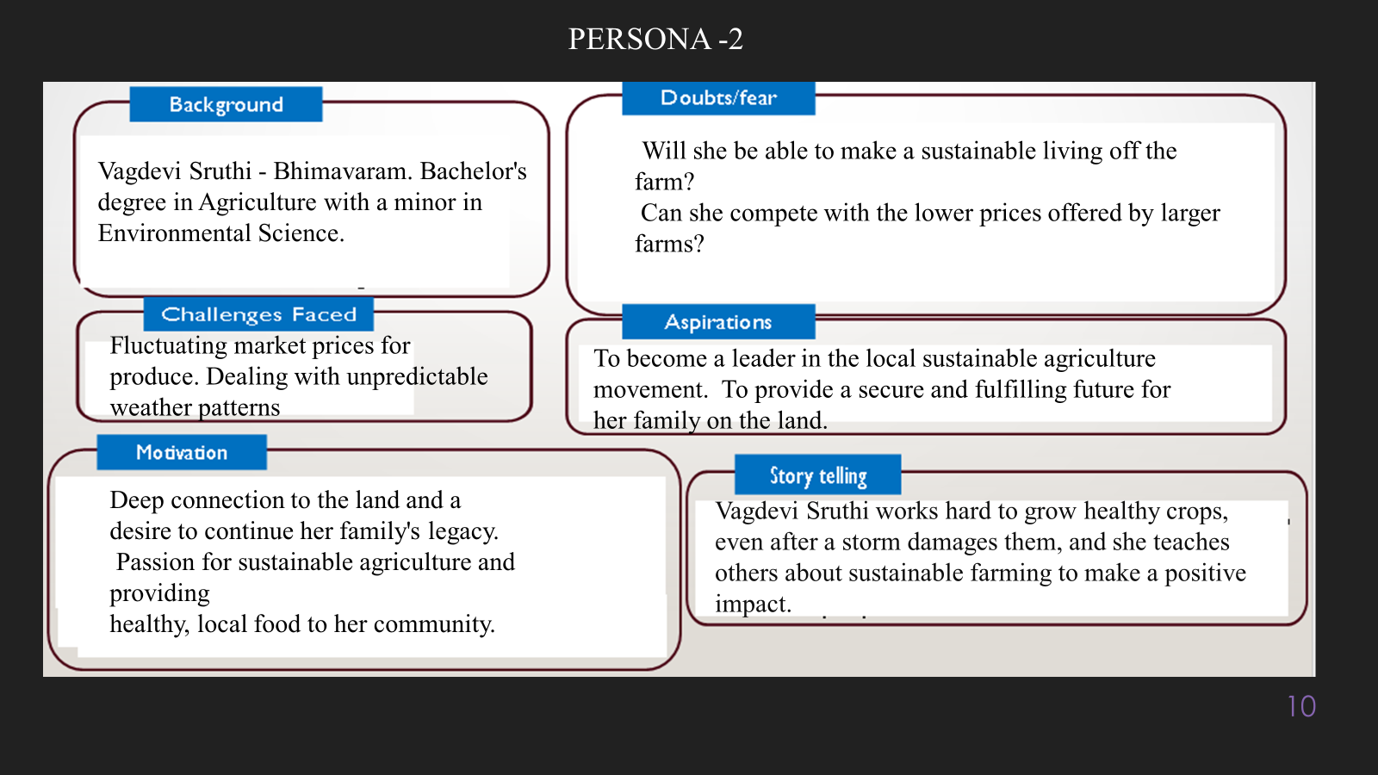

**10. Look for Common Themes, Behaviors, Needs, and Pain Points among the Users**

Analyse the data from your affinity diagram to uncover recurring patterns among your users, helping you better understand their expectations and challenges.

**Common Themes: Identify broad ideas or issues that repeatedly appear across different groups in your affinity diagram.**

**Common Behaviors: Observe how users consistently act or respond in relation to the problem or product throughout their journey.**

**Common Needs: Pinpoint essential requirements or desires that many users share, highlighting what they need for a better experience.**

**Common Pain Points: Look for frustrations or obstacles that frequently hinder the user experience, which your project can address.**

**12. Define Needs and Insights of Your Users**

**User Needs: Define the core requirements your users have in relation to the problem or product. These could be functional, emotional, or societal needs that your solution must address.**

**User Insights: Summarize the key understandings or observations you've uncovered about your users' behaviors, motivations, and pain points. These insights provide a deeper understanding of why users behave the way they do and what drives their decisions.**

**13. POV Statements**

**POV Statements:**

* [User] needs a way to [need] because [insight].

|  |  |  |  |
| --- | --- | --- | --- |
| **PoV Statements**  **(At least ten)** | **Role-based or Situation-Based** | **Benefit, Way to Benefit,**  **Job TBD,**  **Need (more/less)** | **PoV Questions**  **(At least one per statement)** |
| **(Erase this example) When I drive to work, I want to avoid traffic jams so I don’t get in trouble with my boss for being late.** | **A frequent online shopper** needs a way to **quickly identify trustworthy reviews** because they are tired of being misled by fake reviews. | Way to Benefit, Need (more) | What can we design that will enable shoppers to easily filter out fake reviews and focus on genuine feedback? |
|  | **A small business owner** needs a way to **protect their product reputation** because fake negative reviews are unfairly impacting their sales. | Way to Benefit, Need (more) | What can we design that will empower small business owners to effectively combat fake reviews and maintain a positive online image? |
|  |  |  |  |
|  |  |  |  |
|  |  |  |  |

**14. Develop POV/How Might We (HMW) Questions to Transform Insights/Needs into Opportunities for Design**

Turn your user needs and insights into actionable opportunities by framing them as "How Might We" (HMW) questions. These questions will spark creative problem-solving and guide your innovation process.

1. **How Might We: Based on the needs and insights you've identified, create open-ended questions starting with "How might we...?" These questions should aim to solve user pain points, enhance the experience, or address specific needs.**

**Examples:**

* **User Need: "Users need a quicker way to access customer support."**
  + **HMW Question: "How might we create a more efficient and accessible customer support system?"**

* **Insight: "Users feel overwhelmed by too many options."**
  + **HMW Question: "How might we simplify decision-making for our users?"**

**Task:**

**Write 3-5 "How Might We" questions based on your analysis of user needs and insights. These questions should challenge you to think of innovative solutions that can address user problems in meaningful ways.**

**This task encourages participants to think creatively about solving user problems, transforming challenges into opportunities for innovation.**

|  |  |
| --- | --- |
| **User Need/Insight** | **"How Might We" Question** |
| "Shoppers are overwhelmed by the sheer volume of reviews and struggle to quickly identify trustworthy ones." | **How might we...** help shoppers easily and quickly identify reliable reviews among a large number of them? |

**16. Crafting a Balanced and Actionable Design Challenge**

The Design Challenge Should Neither Be Too Narrow Nor Too Broad and It Should Be an Actionable Statement with a quantifiable goal. It should be a culmination of the POV questions developed.

**Design Challenge:** [Actionable Statement]

**17. Validating the Problem Statement with Stakeholders for Alignment**

Ensure your problem statement accurately represents the needs and concerns of your stakeholders and users. This involves gathering feedback from these groups to confirm that the problem is relevant and significant from their perspective. By validating early, you can refine the problem statement to better align with real-world challenges, ensuring your solution addresses the correct issues.

**Validation Plan:**

**Stakeholder/User Feedback (Min. 10 Stakeholders/Experts):**

|  |  |  |  |
| --- | --- | --- | --- |
| **Stakeholder/User** | **Role** | **Feedback on Problem Statement** | **Suggestions for Improvement** |
| Sarah Jones | Small Business Owner | "Yes, absolutely. Fake reviews really hurt my sales. People don't trust my products when they see fake negative reviews from competitors." | "Maybe focus on identifying patterns of fake reviews, like sudden spikes or very similar wording." |
| David Lee | Frequent Online Shopper | "Yes, I've definitely been tricked by fake reviews. It's frustrating to buy something based on good reviews and then it's terrible. I'm always suspicious now." | "It would be helpful if the system could show me a 'trust score' for each review, or highlight reviews that seem suspicious. Also, it should be easy to understand why a review is flagged as potentially fake." |

**18. Ideation**

**Ideation Process:**

|  |  |  |  |
| --- | --- | --- | --- |
| **Idea Number** | **Proposed Solution** | **Key Features/Benefits** | **Challenges/Concerns** |
| **Idea 1** | **"Trust Score" System:** Assign a numerical "trust score" to each review based on automated analysis. | Easy for users to understand review reliability at a glance. Increases transparency. | Defining a fair and accurate scoring algorithm. Potential for manipulation of the score. |
| **Idea 2** | **"Verified Purchase" Filter Enhancement:** Go beyond simple verification and analyze the purchase history of reviewers for patterns. | More robust verification of genuine buyers. Reduces fake reviews from unverified accounts. | Privacy concerns related to accessing purchase data. Complexity of analyzing purchase patterns. |
| **Idea 3** | **Language Pattern Detector":** Focus solely on analyzing the text of reviews for telltale signs of fake reviews, such as repetitive phrases or overly emotional language. | Quick and efficient detection of many fake reviews. Relatively low resource requirements. | Easily bypassed by sophisticated fake review writers. Potential for false positives (flagging genuine, but poorly written, reviews). |
| **Idea 4** | **["Community Reporting & Voting":** Allow users to flag suspicious reviews and let the community vote on their validity. | Leverages the collective intelligence of users. Increases user engagement. | Susceptible to manipulation by organized groups. Potential for biased voting. Requires moderation to prevent abuse. |
| **Idea 5** | **"Reviewer Behavior Analysis":** Track reviewer activity across multiple platforms and identify suspicious patterns, such as sudden bursts of reviews or inconsistent ratings. | Provides a more comprehensive view of reviewer credibility. Helps detect networks of fake reviewers. | Requires access to data from multiple platforms. Privacy concerns related to tracking user activity. |

**18. Idea Evaluation**

Evaluate the Idea based on 10/100/1000 grams

|  |  |  |  |  |
| --- | --- | --- | --- | --- |
| **Idea** | **Impact (10/100/1000 grams)** | **Feasibility (10/100/1000 grams)** | **Alignment (10/100/1000 grams)** | **Total Weight** |
| Fake Review Monitoring System | 800 | 600 | 900 | 2300 |
| Personalized Product Recommendations | 700 | 700 | 800 | 2200 |
| AI-Powered Customer Service Chatbot | 600 | 800 | 700 | 2100 |
| Enhanced Product Image Search | 500 | 900 | 600 | 2000 |
| Real-Time Price Comparison Tool | 850 | 500 | 750 | 2100 |

**Example:**

|  |  |  |  |  |
| --- | --- | --- | --- | --- |
| **Idea** | **Impact (10/100/1000 grams)** | **Feasibility (10/100/1000 grams)** | **Alignment (10/100/1000 grams)** | **Total Weight** |
| **Idea 1** | **1000** | **100** | **1000** | **2100** |
| **Idea 2** | **100** | **1000** | **100** | **1200** |
| **Idea 3** | **100** | **100** | **100** | **300** |

Further, use solution concept form to scrutinize the idea

**Solution Concept Form**

**1. Problem Statement:**

Fake online reviews trick shoppers and hurt honest businesses. We need systems to spot and stop these fake reviews so people can trust what they see online.

**2. Target Audience:**

· **Online shoppers:** So they can trust reviews and buy good products.

* **Businesses:** So they can have fair competition and a good reputation.
* **Online marketplaces:** So they can build trust and keep their platforms reliable

**3. Solution Overview:**

We use smart computer programs to look for patterns and clues that show which online reviews are fake, so only real reviews are seen.

**4. Key Features:**

| **Feature** | **Description** |
| --- | --- |
| Pattern Analysis & Anomaly Detection | This feature uses algorithms to identify patterns in review text, rating behavior, and reviewer profiles. It flags suspicious reviews that deviate from typical patterns, such as sudden spikes in positive reviews or unusually similar wording across multiple reviews. |
| Reviewer Profile Analysis | This feature examines reviewer profiles for inconsistencies or suspicious activity. It analyzes factors like the number of reviews posted, the consistency of ratings, and the presence of verified purchases. It flags profiles that exhibit characteristics associated with fake reviewers. |
| Sentiment & Linguistic Analysis | This feature analyzes the language used in reviews to detect emotional manipulation and fabricated experiences. It identifies reviews with overly positive or negative sentiment, generic or repetitive language, and inconsistencies between the text and the rating provided. |

**5. Benefits:**

| **Benefit** | **Description** |
| --- | --- |
| Increased Trust for Consumers | This system helps shoppers know which reviews are real, so they can make better buying decisions and avoid getting tricked. It builds trust in online shopping. |
| Protection for Honest Businesses | By finding and removing fake reviews, the system helps businesses that play fair. It stops unfair competition from those using fake reviews to boost their products. |
| Saves Time and Money | Businesses don't have to spend hours manually checking reviews. The system does it automatically, saving them time and money. Consumers also save money by avoiding bad purchases. |

**6. Unique Value Proposition (UVP):**

We offer the most accurate and up-to-date fake review detection, giving shoppers real trust and businesses a truly fair online space.

**7. Key Metrics:**

| **Metric** | **Measurement** |
| --- | --- |
| Accuracy of Fake Review Detection | Percentage of correctly identified fake reviews versus genuine reviews. Measured by comparing the system's classifications to a manually verified dataset of reviews. For example, "90% accuracy in identifying fake reviews." |
| Reduction in Reported Fake Reviews | The decrease in the number of fake reviews reported by users or flagged by the system over time. Measured by comparing the number of flagged reviews before and after implementing the system. For example, "25% reduction in reported fake reviews within the first month." |

**8. Feasibility Assessment:**

· We have the computer power and smart programs (AI) needed.

· We can get the review data to analyze.

· We can keep improving the system as fake reviews get trickier.

**9. Next Steps:**

Our next steps are:

* Build a test version of the system.
* Train it with real review data.
* Test how well it finds fake reviews.
* Get feedback from users.
* Make it better and launch it.